A DATA DRIVEN EXPLORATION OF APPLE’S IPHONE IMPACT IN INDIA

INTRODUCTION:

The iphone is a smart phone made by apple that combines a computer, ipod, digital camera and cellular phone into one device with a touchscreen interface. The iphone runs the IOS operating system, and in 2021 when the iphone 13 was introduced, it offered up to 1TB of storage and a 12-megapixel camera.

EMPATHY:

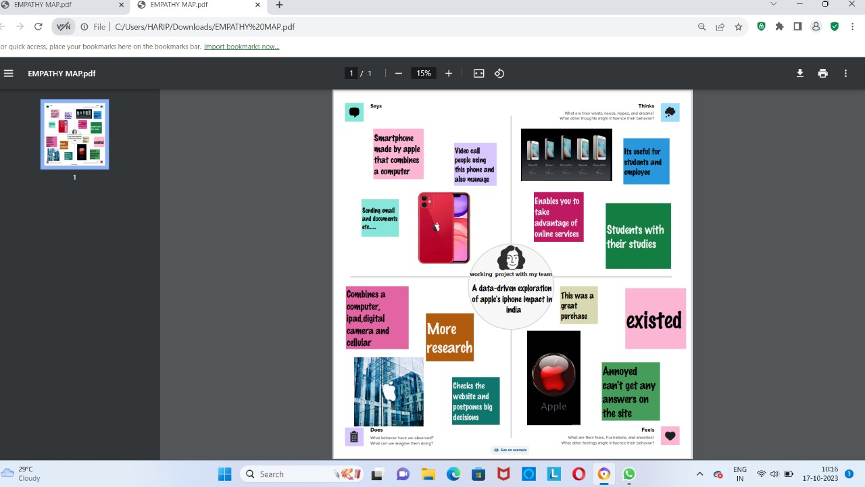

BRAINSTROM MAP:

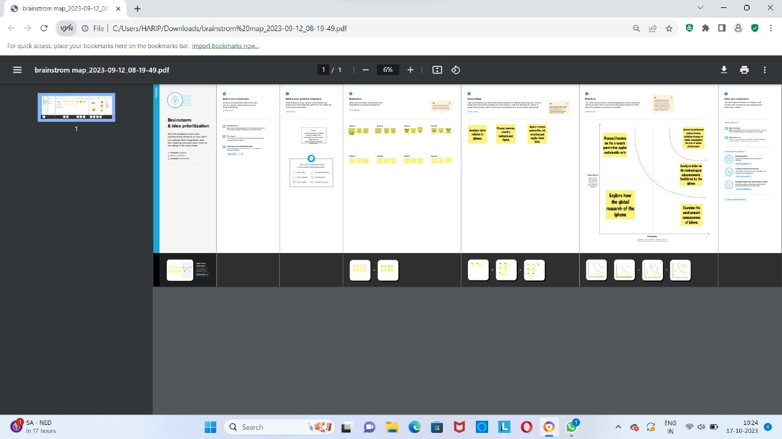

TABLEAU TEXT BOOK:

1.We have taken a dataset and we analysis the data by using tableau.

2. Tableau is the most powerful ,secure, and flexible end to end analytics platform for your data. Elevate people with the power of data.

3. Designed for the individual, but scaled for the enterprise, tableau is the only business intelligence platform that turns your data into insights that drive action.

**DASHBOARD :**

## 

## 

STORY:

